102nd JULY CAMP 2023
Monk’s Cowl
Arrive for lunch, Friday 30thJune. Depart after breakfast, Sunday 9thJuly 2023.

The Cathkin/Champagne Castle area will be explored this year as July Camp will take place at the Ezemvelo Monk’s Cowl Campsite. As this is just North of Injisuthi, many of last year’s Campers would already have had sneak previews of this majestic area from Van Heyningen’s Pass, Wonder Valley Cave and indeed the Injisuthi Campsite itself.

Despite over 100 years of July Camps, this will be our first time in this Central Drakensberg area in which there are many day hike routes and a relatively direct route to the Escarpment.

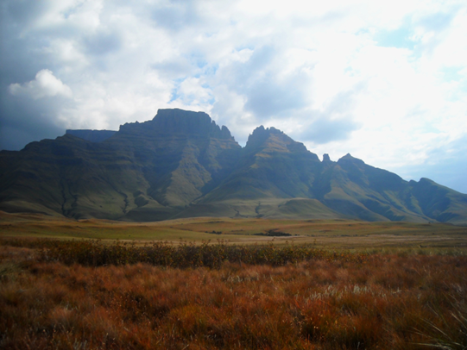
Graeme Bruschi

Unlike the 34 kilometres of dirt road that led to last year’s Camp, this year there is a tarred road all the way to our Base Camp in the Ezemvelo Monk’s Cowl Campsite, (see page 4 for Directions). With full ablution facilities, mown areas for tents in shaded and sunny sites, this Camp will make for a comfortable base from which to start day hikes or overnight sub-camps. Our Campsite is within a two-minute walk from the main parking area where Campers will unload their gear and then move their cars to an adjacent parking area for overnights visitors.

Base Camp runs for 9 nights (30th June to – 8th July Inclusive), to fit in with the school holidays. Campers are welcome to attend for just a few days or for the whole period.

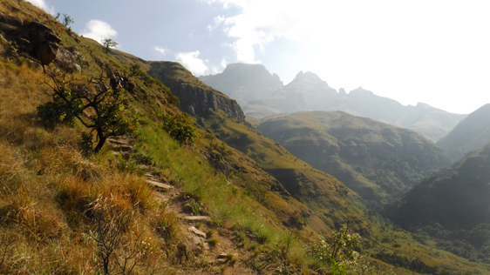
Graeme Bruschi

JULY CAMP 2023 WILL OFFER:

- A dramatic and scenically rugged terrain with lush forests and exhilarating experiences in the Little Berg and on the majestic Escarpment. Bird life is abundant as are varied small species of wildlife. There are excellent opportunities for game viewing, bird-watching, photography and time to absorb the incredible beauty of the area.

- Superb sub-camps in the Little Berg and on the Escarpment.

- Satisfying short walks or long hikes in the Little Berg with stunning views, forests, waterfalls, streams and spectacular rock formations.

- Full catering, a long-established tradition, includes hearty open-fire meals at Base Camp and the standard selection of provisions for sub-camps and day trips.

- An innovation in 2023 is the self-catering option for those who prefer this style of camping.

- All-day coffee and tea provided for ALL Campers.

- A campfire enclosure where, weather permitting, all Campers can gather for a singsong, chat, maybe a drink or two of their own favourite tipple and some of their own snacks. Hot bed-time cocoa will be served.

- Hot-water baths and showers in the Camp’s ablution blocks.

JULY CAMP FEES:
Full Board – R392 pppn (per person per night) or R292 pppn for children under 12.
Included are three meals, beverages and the overnight fees of the Reserve (R160 pppn.)
Self-catering - R242 pppn or R212 pppn for children under 12. Payment includes coffee and tea ad lib and the overnight fees of the Reserve, now R160 pppn. Braai stands are provided in the Campsite.
Non-MCSA members are most welcome and pay an additional R100 once off. This may be redeemed against future membership of KZN Section of the MCSA.
TIPS: Please remember the cooks. These dedicated four men rise at day-break to prepare breakfast and are on duty until after the supper washing up has been completed.
TOUR LED BY COMMUNITY GUIDES: They lead a round trip to the San rock art paintings that takes two to three hours. The cost of this interpretive trail is R900 for the first four people and thereafter R200 per person. Book a Guide at the Camp Office.
MAPS: The Ezemvelo Hiking Map No 2 Cathedral Peak and Monk’s Cowl (R50) and a Monk’s Cowl map (R5) can be purchased from the Monk’s Cowl Office. The MCSA set of Drakensberg maps (R10 each) will be available at our Base Camp.
BOOKING and CANCELLATION: Booking is on a first-come-first-served basis and numbers may be restricted. Please book and pay before 31st May 2023 to avoid disappointment.
REFUNDS: will be given if cancellation notice is received before May 31st 2023. We reserve the right to retain a 20% booking fee after the 31st May 2023.
SUB-CAMP LEADERS: need to book caves for sub-camps, in advance, directly with the Office.
CHILDREN: are our future and are most welcome at July Camp. Children must be accompanied by an adult who will take full responsibility for their welfare and safety.
LEVEL OF FITNESS AND EQUIPMENT: Activities will be of varying levels of difficulty. If joining a group on a strenuous hike, please ensure that you are of comparable fitness so that all will enjoy the experience. The Leaders will describe their trips so please consult them beforehand.

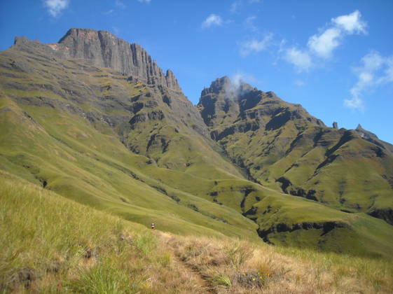
Graeme Bruschi

APPLICATION TO ATTEND
Please use the on-line form using this link

https://forms.gle/ZivvyRAvdKdTW2Au5.
Payment to confirm booking must please be made before 31st May 2023.
EFT PAYMENTS ONLY
MCSA (KZN) Branch STANDARD BANK ACCOUNT NO: 051207141, Branch code: 051001
REFERENCE: JC (for July Camp) then surname and initials

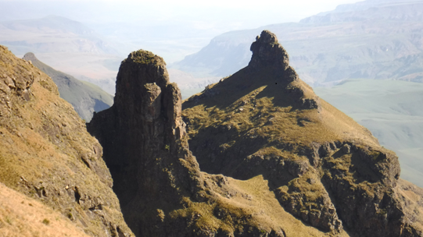
Graeme Bruschi

DIRECTIONS TO BASE CAMP

Access to the Ezemvelo Monk’s Cowl Campsite is from 06:00 to 18:00. Late arrivals please phone ahead. See details under Urgent Messages on page 8.

From DURBAN/PMB, take the N3 toll freeway. Glide off at Exit 179, Estcourt North and turn left towards Loskop. After approximately 30 km on a reasonably well maintained, tarred road through rural settlements and then cultivated farm lands, turn left at the 4-way cross roads (at the Thokoziswe Tourist Centre) and continue towards the Champagne Valley resorts. Then follow that tarred road R600 for about 21 km to the road’s end at the Monk’s Cowl entrance to the Ukhahlamba World Heritage Site.

From GAUTENG, one could take either the N3 toll freeway and then the R74 to Winterton, OR travel through Olivier’s Hoek/ Bergville to Winterton depending on road conditions. On entering Winterton turn right, opposite the petrol garage, go over the railway line, and then follow this R600 road towards the Champagne Valley resorts. Cross straight over the 4-way crossroads at the Thokoziswe Tourist Centre and continue for about 21 kms to the road’s end at the Monk’s Cowl entrance to the Ukhahlamba World Heritage Site.

CHECK-LIST OF ESSENTIAL ITEMS and KIT
Sub-zero temperatures can be expected. Strong winds and snow may occur.

Tent: Please bring your own mountain tent. If you take your Base Camp tent sub-camping, there is a large MCSA tent where you can store excess kit.

Bedding: Bedding rated for sub-zero temperatures at night is essential.

Clothing: Sun-hat and high SPF sun-screen cream. Generally the days are sunny and mild. Waterproof, windproof and warm gear are a necessity along with beanie, scarf and gloves. Suitable boots for hiking and strolling. These should be sturdy, supportive, water- repellant and with strong Vibram–type soles. Comfortable light footwear for Base Camp.

Rucksack: Appropriate to intended activities.

Torch and spare batteries.

Water bottle.

Specific dietary needs, medication and first-aid equipment.

Toiletries: please include biodegradable soap/shampoo and a towel. Lip ice and hand cream are recommended

Zip-lock bags: for day hikes and sub-camps and larger rubbish bags for ALL the rubbish generated.

Mess kits: Please do not rely on Base Camp for eating utensils. You will need two sets of plates, bowls, knives, forks, spoons and mugs. One set is for use in Base Camp and the other on sub-camps and day hikes.

Plastic bucket/basin and biodegradable washing powder: for water and washing clothes.

Sweets, snacks, drinks: to share at the campfire, on sub-camps or on day hikes.

Cash: see Tips, Tour and Map costs on page 3.

MCSA card and passport: You are advised to carry your MCSA membership card always. Passports are required for those who cross into Lesotho.

NB Billy cans, containers and plastic bags are NOT provided for sub-camp catering or day hike lunches so please bring your own. Your Leader will select the best equipment for the trip.

If required:
- Trekking poles.
- Small folding chair or stool. When gathering at the campfire, please place your chair or stool in the rear rows, to allow others to sit on the ground in front of you.
- Maps: May be obtained beforehand from Ezemvelo, P O Box 13609, Cascades, 3202 or customerservice@kznwildlife.com.
- Gas stove, fuel and containers for day hikes, sub-camps and if self-catering at Base Camp. Open fires and candles are NOT permitted anywhere.

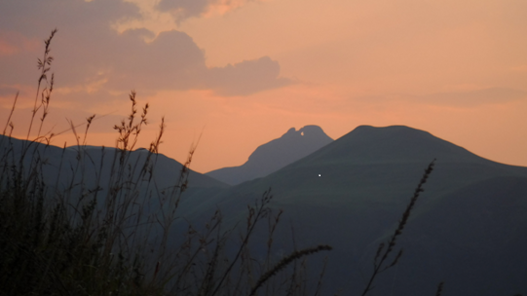
Graeme Bruschi

PLEASE BE REMINDED AT CAMP

SAFETY:
- Sign the Mountain Register at the MCSA Base Camp before you leave on a hike. Minimum group size is three. Indicate the names of each party member and the recognized Leader.

- If going on a day hike indicate your destination and estimated time of return.

- If going on a sub-camp indicate your destination, dates, estimated time of return and major points along your route.

- The Leader is to carry the tear-off stub from the Register. This is vital information for use in the case of any accident or emergency.

- All parties leaving Base Camp are advised to carry water, adequate warm and waterproof clothing, a torch, spare batteries and a cell phone, no matter how short their trip away from Camp.

CATERING:
Self-caterers must be fully self-sufficient for ALL meals in Base Camp, on day trips and on sub-camps. They are very welcome to share the ad lib all day tea and coffee.
Full Board
- Our cooks will provide three meals per day, according to their prepared menu, and all beverages.
- Pre-packed, lightweight food is provided for Leaders to collect for sub-camp trips.
- Leaders who would like to plan their sub-camp catering in advance may request a copy of the food list via e-mail.
- We try to cater for vegetarians by beginning each meal with a vegetable soup and by cooking and serving the vegetables separately. But no specific dish is reserved for them.
- NB If you have specific dietary needs you are advised to provide your own supplements to the basic catered fare.

COOKING AREA:
Although we are drawn to the warmth of the cooking area, do avoid crowding around the fires and pots. Preferably keep out of the way and on the other side of the serving tables while the cooks prepare and/or serve the food.

After each course, basins with boiling water are provided on the serving tables for each of us to wash and rinse our own eating utensils.

To facilitate efficiency and the flow past the serving tables, please help maintain the two separate queues for collecting meals and for washing up.

Second helpings are allowed when all have collected their first helping so preferably be on time when the meal gong sounds.

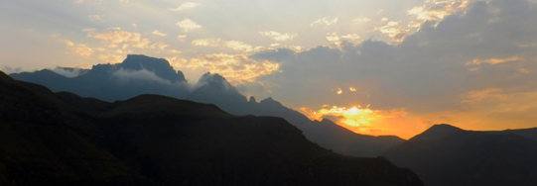
Graeme Bruschi

MCSA KZN JULY CAMP 2023 sub-COMMITTEE

Merv Gavin, Lesley McGwynne, Malikah Makz Parker, Graham Smith, Rikki Abbott Wedderburn

Assisted at Advanced Party by

Henry Coppens, Pam McNamara, Roger Paul, Rev Kev Robertson, Etienne Step, Marilla Vorster

RULES AND REGULATIONS - INCLUDING COMPLIANCE WITH
THE EZEMVELO KZN WILDLIFE ENVIRONMENTAL MANAGEMENT PLAN

July Camp, representing MCSA, endorses a comprehensive system of environmental practices that address, inter alia, conditions of access, admissible structures, services, monitoring, auditing and decommissioning, reinstatement and rehabilitation, pollution and the impact of the event on soil, animals, vegetation and other area users.

WATER QUALITY
The Berg is the main watershed for KwaZulu-Natal, so all Campers are required to use biodegradable soaps and shampoo and to ensure that grey water is dispersed directly onto a grassed area and not into a watercourse. When out of Base Camp, all Campers are required to observe bush-toilet etiquette.

SOIL CONSERVATION
No soap/shampoo of any kind to be used in the streams and rivers. Please wash and rinse yourself, your hair and your clothes on the bank, sufficiently far from the river so that the water does not flow directly back into the river or stream.

WASTE
The principle of ‘what we carry in, we carry out’ applies. Participation in July Camp is on the understanding that each Camper will carry out all the rubbish he/she generates both in Base Camp and on day trips and sub-camps.

NOISE is not permitted.
This includes technically augmented music, radios and drones. The sense of peace and nature’s environment is not to be disturbed or invaded.

MONITORING
The site is monitored for environmental impact before and after the event.

FLORA and FAUNA
If any sensitive species (e.g. vulture, lammergeyer or oribi) are seen, please notify the Office promptly so that the KZNWildlife specialists can be kept informed.

OPEN FIRES are not permitted anywhere.
A very special concession is made for the Base Camp catering team and for our evening campfires within a screened enclosure. Both are strictly controlled.
__________________________________________________________________

URGENT MESSAGES: From Monday 26th June and for the duration of July Camp 2023, our cell phone range is limited so urgent messages may be directed through the Monk’s Cowl Camp Manager: Ms Thakasile Zondi, at 036 468 1103/2 (office hours) or 072 880 1536 (after hours) or Mark Robertson, at 083 608 3742 (after hours).

FURTHER INFORMATION and ENQUIRIES:
Rikki Abbott Wedderburn, Mobile 082 538 5389 Landline 033 239 2374
E-mail: ronwedd@netactive.co.za

APPENDIX I

Venues of July Camps since 2006

2006 Cathedral Peak, Research Catchments VI and VII, Masongwana
2007 Royal Natal National Park, Sungabala
2008 Duart Castle
2009 Giant’s Castle, Chimney Pot (Maqomfa, 1894m)
2010 Crystal Waters (private farm)
2011 Injisuthi Campsite
2012 Cobham
2013 Wonder Valley (private farm)
2014 Vergelegen
2015 Highmoor
2016 Lotheni
2017 Cathedral Peak, Cambalala Cottage, Cathedral Peak (Rented by KZN Section MCSA for 49 years! Celebrating 50 years in September 2023!
2018 Crystal Waters (private farm)
2019 JULY CAMP CENTENARY Cobham Campsite
2020 Covid
2021 Covid
2022 Injisuthi Campsite
2023 Monk’s Cowl Campsite

